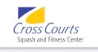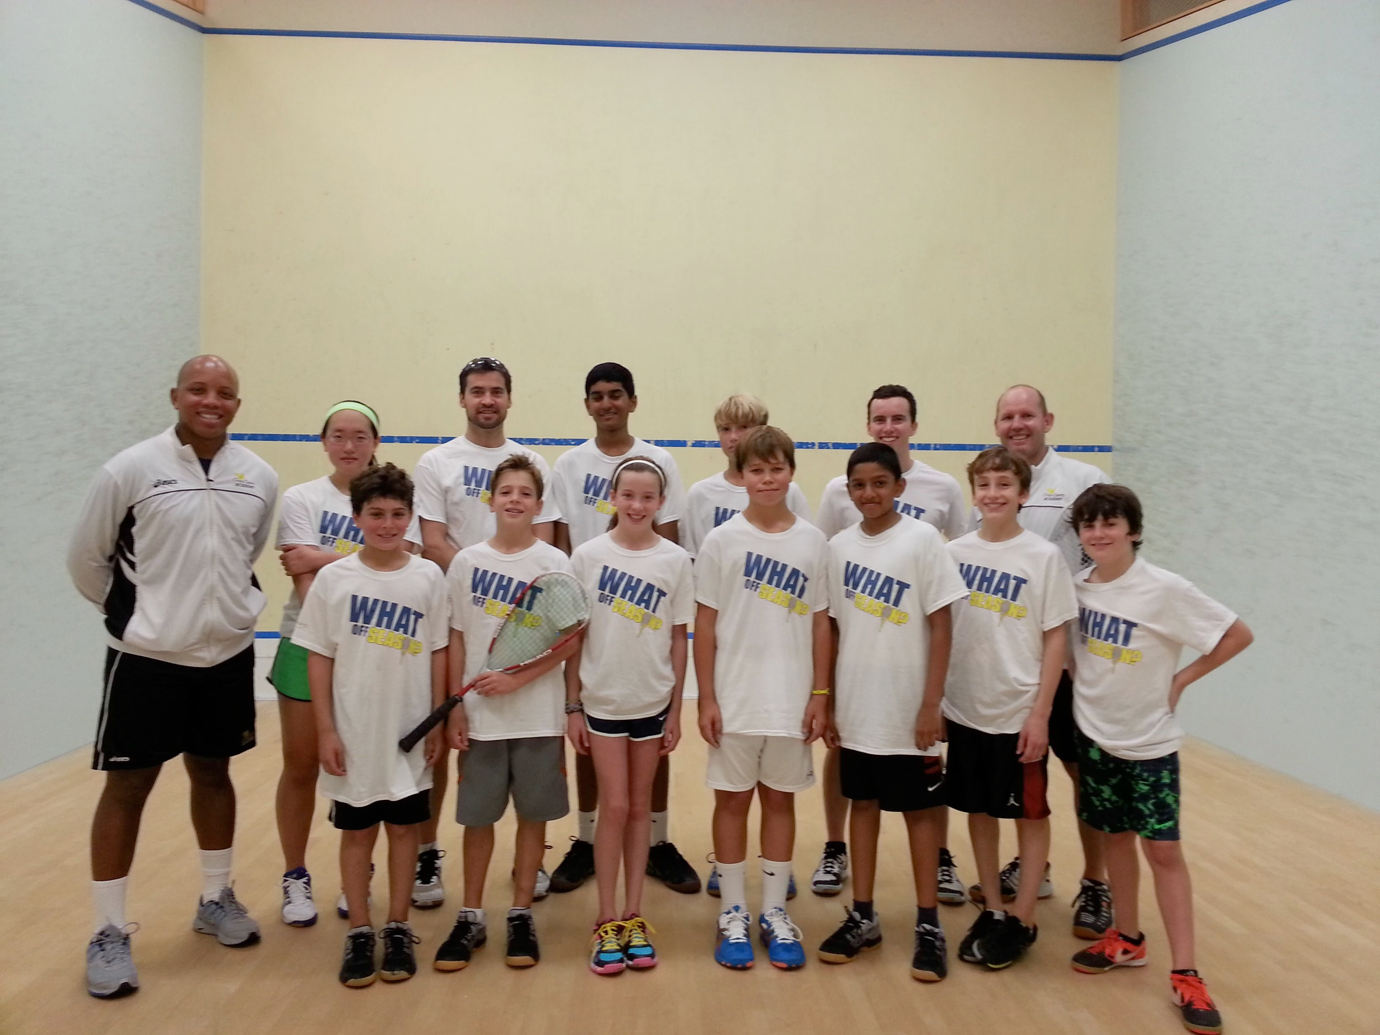

Summer Squash & Fitness Camps

2015

Dates:

Session 1: June 22-26

Session 2: June 29-July 2*

Session 3: August 10-14

Session 4: August 17-21

*4 day session

***Squash Schedule***

**June 22-26 & June 29-July 2* (4 day session, Mon.-Thurs.)**

9:30am-11:00am Novice (ages 7-9)

11:00am-1:00am Intermediate (ages 10-12)

2:00pm-4:00pm Advanced (ages 13-17)

**August 10-14 & August 17-21**

9:30am-11:00am Novice (ages 7-9)

11:00am-1:00am Intermediate (ages 10-12)

2:00pm-4:00pm Advanced (ages 13-17)

***Training Overview***

Summer is the perfect opportunity for players to make changes and improvements to technique in preparation for the fall tournament and winter school squash seasons. For the beginner to the tournament player, these camps are designed to improve stroke technique, tactical play, and footwork and squash conditioning. A typical training day will consist of a fitness workout and then an on-court session of solo drilling, coaches feeding balls, pairs drilling, footwork drills, and match play practice.

Coaches

Daniel Sharplin, Simba Muhwati,

Gary Gargan, & Alex Grayson

***Fitness Schedule*** (open to intermediate/advanced players)

This summer we will be offering a fitness program designed to prepare our elite athletes for success on the court. This program is designed to develop the strong fitness base that is critical for success on the courts. Sessions are open to intermediate and advanced players, but are highly recommend for our serious tournament players.

10:00am-11:00am daily

at Cross Courts

Weekly costs

$295 Novice session

$395 – Int/Adv. Squash Only

$545 – Int/Adv. Squash & Fitness

* *June 29-July 2* is a 4 day session. Cost: $235 for Novice & $315 for Int/Adv esessions

**Camps are open to members and non-members.**

.

*Weekly cost for squash & fitness is non-refundable and there will be no pro-rated fees for non-attendance.

Checks should be made out to ***“Squashfit***.”

Dates

Session 1: June 22-26 Squash only Squash & Fitness

Session 2: Jun 29-Jul 2 Squash only Squash & Fitness

Session 3: August 10-14 Squash only Squash & Fitness

Session 4: August 17-21 Squash only Squash & Fitness

Circle player level:

Novice Intermediate Advanced

Cross Courts Squash & Fitness

Summer Camp Registration

2015

Player Information

Player Name………………………………………………………Age…………………….........

Parents Name(s)…………………………………………………………………………............

Address…………………………………………………………………………………………….

Email……………………………………………………………………………………………….

Phone number (cell)…………………………………….(work)………………………………..

Clothing Size (please circle)......YM..........YL.........YXL.........S............M..........L................

Payment Information (please make checks out to “Squashfit.”)

Card Number..........................................................................Exp. Date...............................

Type of card (please circle)........MC.............Visa............AMEX.............Discover................

Name (as it appears on card):...............................................................................................

Billing Address.......................................................................................................................

Security Code (on back of card, front of card on AMEX):...........................................

**Signature**........................................................................................**Date:**...........................

Release of Liability

I hereby do not hold Cross Courts Squash& Fitness Center, or any of its staff, responsible for any accident or injury sustained to my son/daughter while participating in activities at the club.

**Signed**:................................................................................**Date**:..............................................